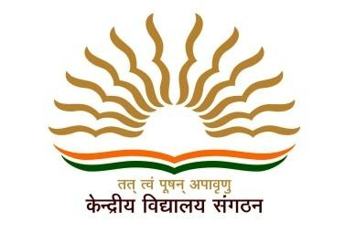

Kendriya Vidyalaya No.2 Uppal (SOI)

CERTIFICATE OF PARTICIPATION

We appreciate

Md. Abdhul Qudhus of 10 B

for participating in the Online Quiz conducted by the Vidyalaya as part of

Fit India School Week December 2020

