Kendriya Vidyalaya No.2 Uppal, SOI
CBSE AISSCE Results (2020-2021)
- Class XII Result:-
No. Appeared | No.Passed | No.of students failed/compartment | Pass % | School PI | Regional PI
39 | 39 | 0 | 100 % | 55.96 | 63.11
- 38 out of 39 students secured 60% & above marks.
- Kakani Sri Pravallika and Syeda Fatimah secured 16th position in the region (94.8%).
- Talluri Pratimah secured 17th position in Regional level (94.6%)
- List of toppers
S.No | Name of the student | Marks out of 500 | Percentage | Photo
1 | KAKANI SRI PRAVALLIKA | 474 | 94.8 | 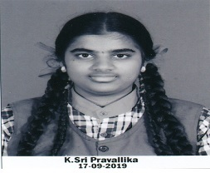
2 | SYEDA FATIMAH | 474 | 94.8 | 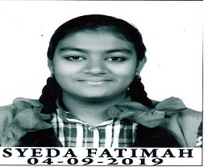
3 | TALLURI PRATHIMA | 473 | 94.6 | 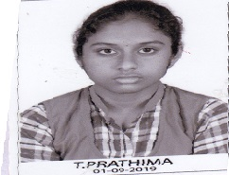
Performance index and pass% Subject wise of Class XII(2021):-
Subject | Pass % | PI | Regional PI
English Core | 100 | 62.18 | 64.33
Hindi Core | 100 | 87.5 | 67.77
Physics | 100 | 60.9 | 66.93
Chemistry | 100 | 58.33 | 64.33
Mathematics | 100 | 42.42 | 58.35
Biology | 100 | 53.57 | 61.09
Computer Science | 100 | 46.5 | 56.91
Physical Education | 100 | 67.95 | 57.66

Kendriya Vidyalaya No.2 Uppal, SOI
CBSE AISSE Results (2019-2020)
- Class X Result:-
No. Appeared | No.Passed | No.of students failed/ in compartment | Pass % | P.I | Regional PI
100 | 100 | 0 | 100 % | 58.70 | 64.58

- Rokkala Meghana and Dandeboyina Sai Teja secured A1 Grade in all subjects.
- Rokkala meghana stood at19th position in the region by securing 95.6%.
- Dandeboyina Saiteja stood at 20th position in the region by securing 95.4%.

- List of toppers
S.No | Name of the student | Marks out of 500 | Percentage | Photo
1 | ROKKALA MEGHANA | 478 | 95.6
2 | DANDEBOYINA SAI TEJA | 477 | 95.4 | 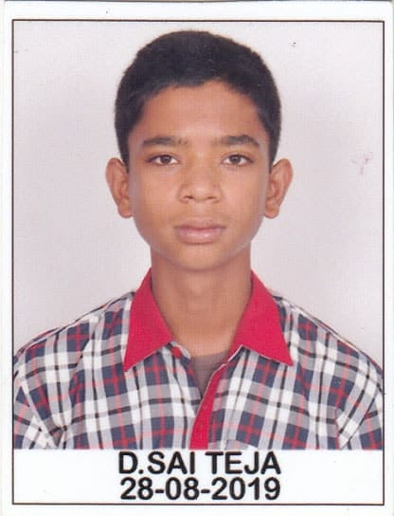
3 | POTU DIYA REDDY | 470 | 94 | 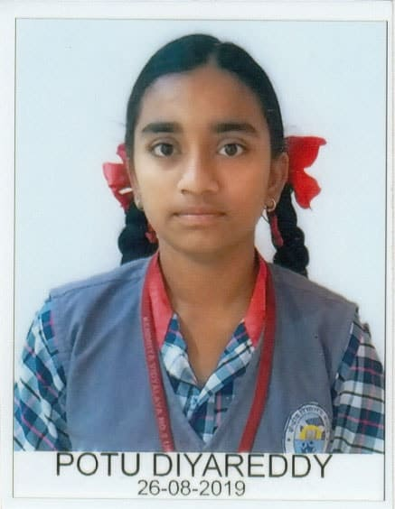

Performance index and pass% Subject wise of Class X:-
Subject | Pass % | PI | Regional PI
English Lang. & Literature | 100 | 68.25 | 65.21
Hindi Course -A | 100 | 51.41 | 64.64
Sanskrit | 100 | 69.38 | 77.95
Mathematics-Standard | 100 | 67.86 | 71.05
Mathematics- Basic | 100 | 42.88 | 49.82
Science -Theory | 100 | 62.63 | 64.74
Social science | 100 | 57.75 | 60.26
Information Technology | 100 | 53.88 | 60.58
German | 100 | 63.64 | ------

